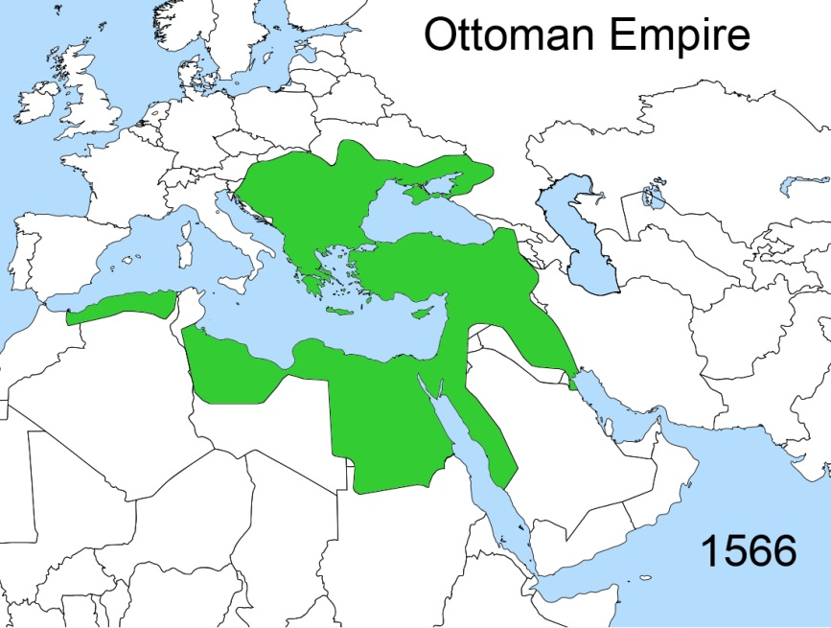
Event A: The Decline of the Ottoman Empire

The Ottoman Empire ruled much of present day Middle East from approximately 1300 to its collapse after World War I in 1918. The majority of the empire was Muslim but the empire contained many different religions and ethnic groups. The diverse population was governed through the millet system which allowed religious groups to govern themselves as long as they paid taxes that supported their ruler, the sultan. The millet system of indirect rule allowed diverse communities to live peacefully in the Ottoman Empire for hundreds of years.
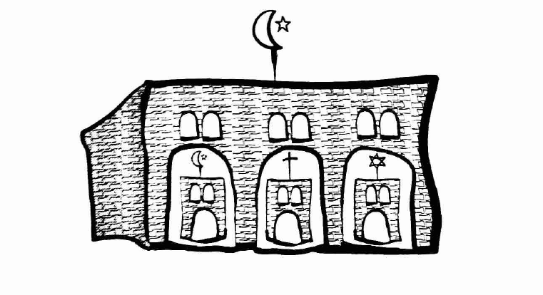
In the late 1700s to late 1800s however the Ottoman Empire began to reform to become more like the Europeans. Conflict between the European influenced reformers and traditional Ottoman Empire followers caused growing tension within the empire. In 1908 a group of Western influenced revolutionaries called the Young Turks overthrew the sultan and reestablished a European style government in the Ottoman Empire
Event B: The World War I Peace Settlement
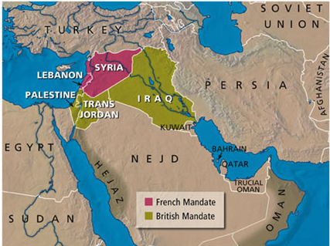
During World War I the Ottoman Empire fought with the Central Powers until losing the war in 1918. Britain and France took over the region and made the Sykes Picot Agreement where they agreed to divide up the land into mandates or colonies. Britain and France created six new nations and borders that served their own interests. For example they abolished the millet system, had western style government and economic policies, and choose their own European rulers that supported their interest. The majority of the people living in these areas resented the intervention of the Europeans finding themselves now divided or put into new nations they had no ethnic, religious, or cultural connection to.
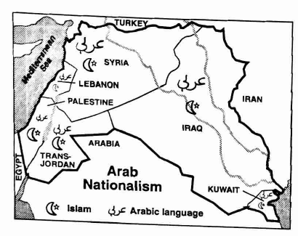
Event C: The Rise of Arab Nationalism
Some Arab leaders of the former Ottoman Empire responded to European intervention by calling for unity and independence. The leaders of this movement believed that the Arabic language united all people regardless of their different religions and that their loyalty should be with their fellow Arabs, not to their European rulers.
Other rulers believed that their common religion, Islam, should unite the people. They believed the only way to do this was to force out the Europeans and choose leaders who respected and protected the laws and customs of Islam. Together the Arab nationalist and Muslims across the Middle East engaged in demonstrations, boycotts, and writing campaigns against European colonial powers.
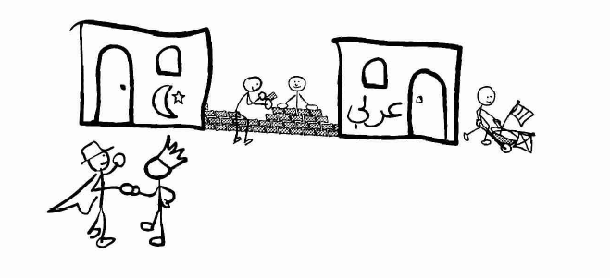
Still others realized they did not have the ability to fight off the Europeans and worked alongside the British and French hoping to govern in partnership that would eventually allow them to rule themselves according to Middle Eastern customs.
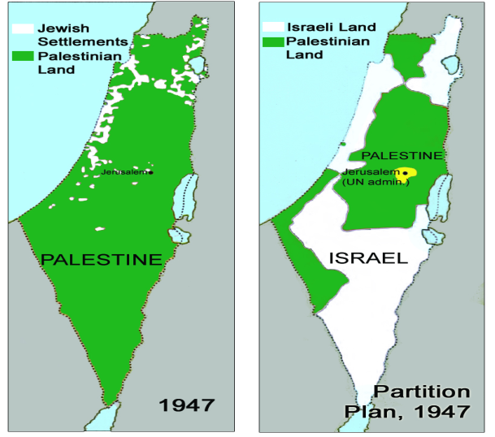
Event D: The Partition of Palestine

Since the 1st century when the Jews were pushed out of Palestine by the Romans they have wanted to return to their homeland. In the late 1800s Zionism- Jewish nationalism focusing on creating a Jewish state in Palestine- was formed. Zionist leaders appealed to Britain to allow them to migrate back to Palestine. In 1917 British officials created the Balfour Declaration which proclaimed Britain’s support for the creation of a Jewish national home in Palestine. Zionist interpreted this declaration to mean that Britain supported unlimited Jewish immigration into Palestine and eventually create their own Jewish state.
Palestinians Arabs strongly opposed the Balfour Declaration feeling as though the British were giving away their ancestors homeland without even consulting them. In 1936-1939 an armed revolt occurred that the British army crushed after much violence and death.
British leaders could not bring the Palestinians and Jews together so in 1937 they decided to break apart Palestine into a Jewish and Arab state. The Jews tentatively agreed while the Palestinian Arabs strongly opposed the plan. More violence occurred before Britain abandoned their plan. After World War II the British declared they could no longer control the violence in Palestine and turned the region over to the United Nations who developed a partition plan in 1947.

Event E: The Partition of Lebanon and Syria
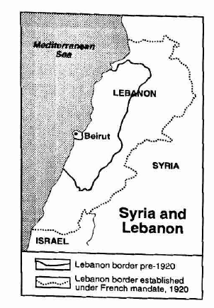
Lebanon: After World War I France controlled the regions of Lebanon and Syria. The majority of the inhabitants of Lebanon were Maronites, a type of Arab Christians that has a historically close relationship with the French. Instead of keeping the traditional border the French increased the borders of Lebanon to include land that was primarily inhabited by Muslims even though most of these Muslims wanted to be part of Syria, the neighboring Muslim governed state. To honor their historical relationship the French allowed the Maronites who now only made up 40 percent of the population political and economic control of the Muslims in Lebanon.
Syria: After World War I Syria became the center of Arab nationalism. In 1920 Syria proclaimed itself an independent state. However, according to the Sykes-Picot Agreement France claimed Syria as a French colony. The French army entered Syria attempting to weaken Arab nationalism by dividing Syria up into four provinces split up by ethnic groups. The French initially stopped the movement however it only further inspired Syrians to form nationalist parties that worked to gain independence. Their efforts were supported by Arabs throughout the Middle East who were outraged by France’s actions and believed that Arabs had the right to choose their own form of government. In 1946 the French left Syria feeling that would no longer control Arab nationalism.
Event F: The Formation of Iraq and Kuwait
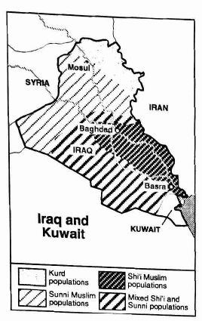
Iraq: After World War I Britain combined various Ottoman Empire provinces to create Iraq. Various religious groups were included in this area with Shi’i Muslims in the south, Sunni Muslim in the center, and Kurdish Muslim and Assyrian Christians in the north. Hoping to avoid the problems the French experienced in Syria the British allowed Iraq some say in the government using indirect rule. The British allowed them to have a king that supported their own interests and gain their independence in 1930. After the kings death in 1933 the Sunni Muslims took over the government with one ethnic group now dominating the region.
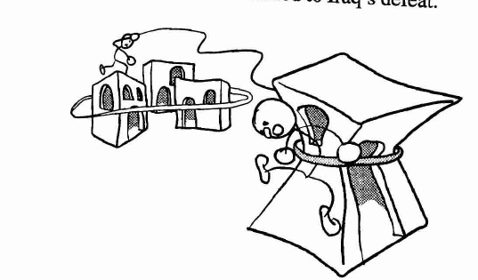
Kuwait: In the 1700’s the region of Kuwait was part of the Ottoman Empire controlled by one family the al-Sabah family. In the 1800’s Britain became interested in the region because of its access to trade routes and signed a treaty of protection with the al-Sabah family in 1899 and ruled the area as a colony in 1961 when Kuwait became independent. In 1990 Iraq invaded Kuwait saying historically that region belonged to them. The invasion developed into the Gulf War which involved the United States and led to Iraq’s defeat.

