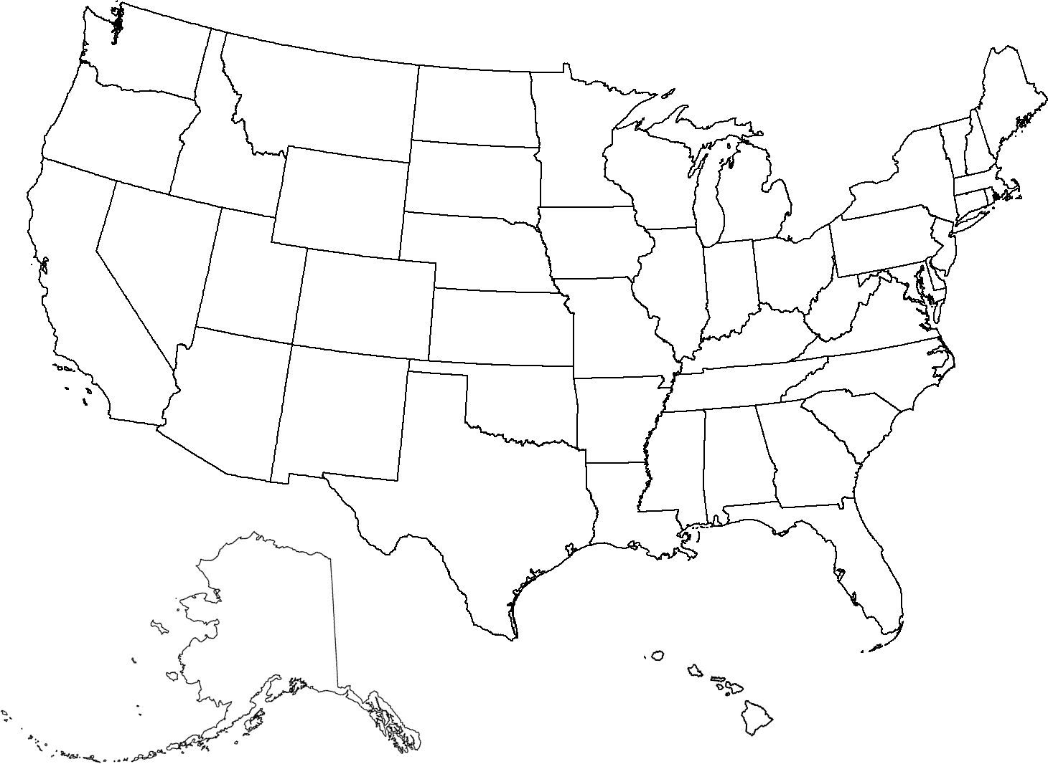

Printable Maps By: WaterproofPaper.com More Free Printables: Calendars Maps Graph Paper Targets

